Additional tables
Table S1 Characteristics of the patients according to the outcome
Characteristics | Survivors  (n=2921) | Non-survivors  (n=929) | P value
Age, Mean ±SD | 58.9±17.9 | 71.0±14.7 | < 0.001
Sex, male (%) | 1906 (65.3) | 595 (64.0) | 0.503
Severity admission, median (IQR)
APACHEII | 15.0 (10.0 - 20.0) | 25.0 (20.0 - 30.0) | < 0.001
SOFA-Initial | 8.0 (6.0 - 9.0) | 10.0 (8.0 - 13.0) | 0.337
Main diagnosis, n (%) |  |  | < 0.001
Sepsis | 764 (26.2) | 494 (53.2)
Respiratory disease | 540 (18.5) | 167 (18.0)
Cardiovascular disease | 240 (8.2) | 59 (6.4)
Neurological disease | 193 (6.6) | 46 (4.9)
Trauma | 213 (7.3) | 27 (2.9)
Postoperative care | 511 (17.5) | 47 (5.0)
Gastrointestinal disease | 249 (8.5) | 51 (5.5)
Others | 211 (7.2) | 38 (4.1)
Comorbidities, n (%)
Respiratory disease | 176 (6.0) | 114 (12.3) | < 0.001
Cardiovascular disease | 457 (15.6) | 206 (22.2) | < 0.001
Hypertension | 911 (31.2) | 410 (44.1) | < 0.001
Diabetes mellitus | 494 (16.9) | 222 (23.9) | < 0.001
Chronic renal failure | 145 ( 5.0) | 100 (10.8) | < 0.001
Cancer | 264 (9.0) | 109 (11.7) | 0.016
Cirrhosis | 75 (2.6) | 31 (3.3) | 0.212
None | 979 (33.5) | 166 (17.9) | < 0.001
Treatment
MV, n (%) | 1965 (67.3) | 801 (86.2) | < 0.001
RRT, n (%) | 345 (11.8) | 281 (30.2) | < 0.001
Length of stay, days (IQR)
Hospital | 19.0 (12.0 - 28.0) | 18.0 (19.0 -27.0) | 0.743
ICU | 7.0 (4.0 - 13.0) | 11.0 (6.0 - 19.0) | 0.025
SD, standard deviation; APACHE II, Acute Physiology and Chronic Health Evaluation II; SOFA, Sequential Organ Failure Assessment; IQR, interquartile range; ICU, intensive care unit; MV, mechanical ventilation; RRT, renal replacement therapy.

Table S2 Characteristics, therapies and outcomes of the patients after propensity score matching
Characteristics | MFO < 5 %  (n=1078) | MFO ≥5 %  (n=1078) | P value
Age, Mean ±SD | 62.9±17.9 | 62.3±17.9 | 0.421
Gender, male (%) | 416 (70.3) | 398 (67.2) | 0.195
Severity admission, median (IQR)
APACHEII | 18.0 (13.0- 26.0) | 18.0 (13.0- 24.0) | 0.497
SOFA-Initial | 8.0 (6.0- 9.0) | 8.0 (6.0- 9.0) | 0.337
Main diagnosis, n (%) |  |  | 0.972
Sepsis | 390 (36.2) | 389(36.1)
Respiratory disease | 222 (20.6) | 227(21.1)
Cardiovascular disease | 60 (5.6) | 46 (4.3)
Neurological disease | 73 (6.8) | 72 (6.7)
Trauma | 67 (6.2) | 67 (6.2)
Postoperative care | 124 (11.5) | 126 (11.7)
Gastrointestinal disease | 78 (7.2) | 85 (7.9)
Others | 64 (5.9) | 66 (6.0)
Comorbidities, n (%)
Respiratory disease | 99 (9.2) | 95 (8.8) | 0.763
Cardiovascular disease | 188 (17.4) | 191 (17.7) | 0.865
Hypertension | 413 (38.3) | 410 (38.0) | 0.894
Diabetes mellitus | 221 (20.5) | 222 (20.6) | 0.957
Chronic renal failure | 82 ( 7.6) | 78 (7.2) | 0.742
Cancer | 91 (8.4) | 82 (7.6) | 0.476
Cirrhosis | 24 (2.2) | 34 (3.2) | 0.183
None | 297 (27.6) | 275 (25.5) | 0.283
Treatment
MV, n (%) | 803 (74.5) | 811 (75.2) | 0.691
RRT, n (%) | 177 (16.4) | 194 (18.0) | 0.332
Mortality, n (%)
In hospital | 248 (23.0) | 311 (28.8) | 0.002
In ICU | 226 (21.0) | 297 (27.6) | <0.001
Length of stay, days (IQR)
Hospital | 21.0 (14.0 - 30.0) | 21.0 (13.0 - 31.0) | 0.743
ICU | 10.0 (6.0 - 18.0) | 10.0 (7.0 - 19.0) | 0.025
SD, standard deviation; APACHE II, Acute Physiology and Chronic Health Evaluation II; SOFA, Sequential Organ Failure Assessment; IQR, interquartile range; ICU, intensive care unit; MV, mechanical ventilation; RRT, renal replacement therapy.

Table S3 Results of the Cox proportional hazard regression analysis of the risk of hospital mortality after propensity score matching
 | MFO* |  |  | MFO stratified by percentage
 | HR (95% CI) | P value |  | MFO < 5% (n = 1078)  Reference | 5% ≤ MFO< 10% (n = 553)  HR (95% CI) | MFO ≥ 10% (n = 525)  HR (95% CI)
Model 1 | 1.04 (1.02 - 1.05) | < 0.001 |  | 1.000 | 1.27 (1.02 - 1.57) | 1.46 (1.203 – 1.79)
Model 2 | 1.04 (1.03 -1.05) | 0.001 |  | 1.000 | 1.23 (1.00 - 1.52) | 1.43 (1.17 – 1.75)
Model 3 | 1.03 (1.02 -1.05) | < 0.001 |  | 1.000 | 1.17 (0.95 - 1.45) | 1.45 (1.19 – 1.77)
Model 4 | 1.03 (1.02 -1.04) | < 0.001 |  | 1.000 | 1.14 (0.92 - 1.40) | 1.41 (1.18 - 1.66)
*MFO was entered as a continuous variable per 1% (L/kg) increase. Model 1, crude HR. Model 2, adjusted for age, sex, APACHE II score and center. Model 3, additionally adjusted for the main diagnosis and comorbidities. Model 4, additionally adjusted for mechanical ventilation, renal replacement therapy, and use of vasopressors. MFO, maximum fluid overload. HR, hazard ratio.

Additional figures

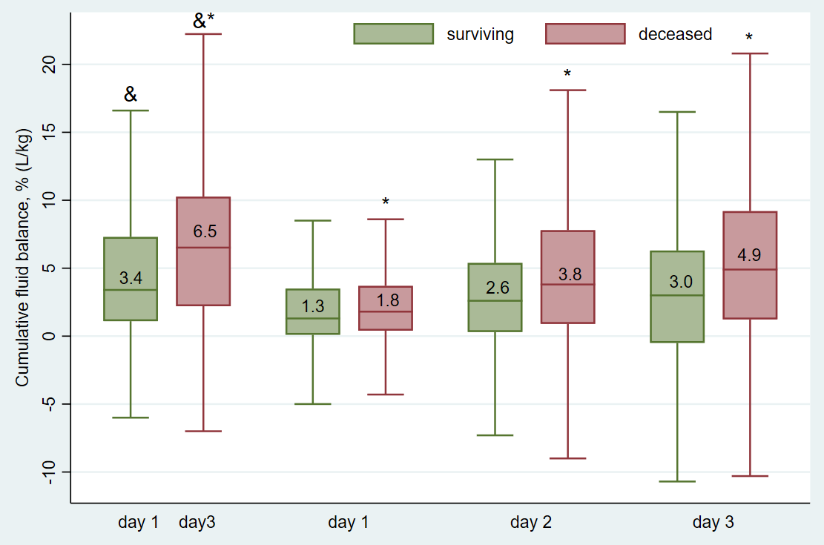
Fig. S1 Cumulative fluid balance and maximum fluid overload (&) in the first 3 days on admission ICU according to the survival status of patients. &, maximum fluid overload. * p < 0.001.

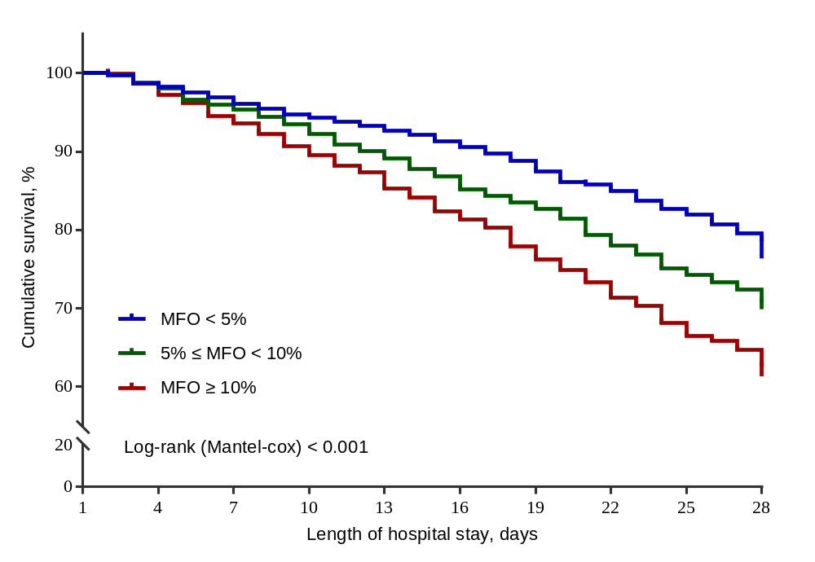
Fig. S2 Kaplan-Meier survival curves estimating the cumulative probabilities of 28-day survival for all patients stratified by the categories of MFO values. The patients with an MFO ≥ 10% L/kg had the lowest 28-day survival (log-rank test, p < 0.001). MFO, maximum fluid overload.

